Journal of CosmetiC and laser therapy http://dx.doi.org/10.3109/14764172.2015.1052513

CASE REPORT
Fractional treatment of aging skin with Tixel, a clinical and histological evaluation
Monica Elman1, Nathalie Fournier2, Gilbert Barnéon3, Eric F. Bernstein4, and Gary Lask5
1elman laser Clinic, rishon le-Zion, israel; 2Cldp, Clapiers, france; 3Centre pathology, montpellier, france; 4main line Center for laser surgery, ardmore, pa, usa; 5uCla medical school, los angeles, Ca, usa

ArtIcLE HIstOrY
contact duration and to thermal conductivity. The D tip created char-free ablative craters 100–320 μm wide with a thermal zone 100–170 μm deep. The S tip created non-ablative coagulation preserving the epidermis. Skin complexion improvement was achieved in all subjects; average treatment pain of 3.1/10, downtime of 0–1 days, and erythema clearance of 3.5 days. Subject’s satisfaction was 75% and wrinkle attenuation was achieved in 75% of the cases. There was no incidence of bleeding, scarring, or post-inflammatory hyperpigmentation. Conclusions: Tixel may be used safely for ablative and non-ablative resurfacing with low pain, low downtime, and quick healing.
addition, histopathologies of Tixel and CO2 laser were performed. Results: Crater properties are related to
AbstrAct
Objective: This study presents clinical results of Tixel, a new fractional skin resurfacing system based on thermo-mechanical ablation technology. Tixel employs a hot (400°C) metallic tip consisting of 81 pyramids. Treatment is performed by rapidly advancing the tip to the skin for a preset tip–skin contact duration. Thermal energy transfer to the skin creates micro-craters by evaporation. Methods: Treatment results with tip types, D and S, with high and low thermal conductivity, were evaluated. Twenty-six subjects received three facial treatments, with 4–5-week intervals between treatments, without analgesia or cooling. In
received 9 december 2014
accepted 12 april 2015
KEYWOrDs
ablation; fractional; resurfacing; skin rejuvenation; thermal model

Introduction
Fractional laser resurfacing technologies are widely used in dermatology. Short-pulse CO2 lasers are generally considered to be among the best modalities for high-precision ablation of thin tissue layers without bleeding and with minimal collateral damage (1). They are widely utilized in skin fractional skin resurfacing (2,3) for improved skin texture and fine wrinkles. Treatment is painful, requiring pre-application of analgesic creams and protective eyewear. Downtime is about 5 days. With a penetration depth of only 30–50 μm by the 10.6-μm wavelength laser beam into tissue, it is possible to vaporize crater arrays of skin down to the papillary dermis or deeper, and achieve excellent skin resurfacing results. With an array of ∼100–250 μm focused beam spots, fractional resurfacing of
∼12–20% of the skin surface ensures fast healing. The energy responsible for vaporization of tissue with a CO2 laser is purely thermal. In the vaporization process, the temperature pro- duced by a single-pass laser beam attains ∼350–400°C in the crater (4).
Since thermal energy causes tissue vaporization, one may expect that by bringing a metallic element having high thermal conductivity, heated to a temperature of ∼350–400°C, in contact with the skin for a duration of a few milliseconds and a depth of ∼50–150 μm, an ablative effect which is clinically identical to the CO2 laser effect will occur.
The objective of the current article is to present a novel thermo-mechanical ablation (TMA) technology and to show
clinical and histopathology data using the Tixel device. A com- parison to fractional CO2 laser histology is also provided.

Materials and methods

The Tixel
The Tixel (Novoxel, Germany) is a thermo-mechanical system for fractional ablation. It applies a tip, made of metallic, gold- plated biocompatible materials (Figure 1A). The tip is fixated at the distal section of the Tixel’s handpiece which is equipped with a linear motor (Figure 1B). The tip’s active surface con- sists of an array of 81 (9  9) pyramids evenly spaced within

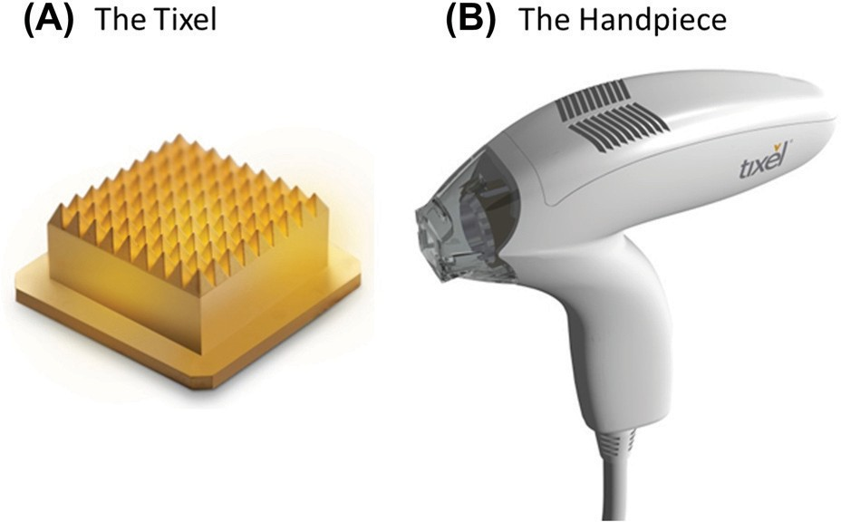
Figure 1. (a) d and s types of tixel pyramidal tip array. (B) tixel handpiece.

CONTACT Gary lask ilrderm@gmail.com uCla medical school, los angeles, Ca, usa. monica elman and nathalie fournier are equal contributors to this paper.
Color versions of one or more of the figures in the article can be found online at http://www.tandfonline.com/ijcl
© 6 taylor & francis Group, llC

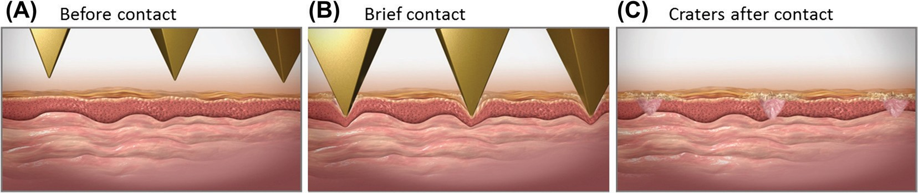
Figure 2. schematic of the crater array vaporization process with high-temperature pyramidal tips. (a) fast advance toward tissue; (B) Brief contact on skin surface and transfer of thermal energy to tissue; (C) Vaporized craters after tips retraction. temperature of 400°C and short contact duration are identical to Co2 laser parameters, and ensure a tissue interaction which is very similar to Co2 (or erbium) lasers.

a boundary area of 1  1 cm. The pyramids are 1.25 mm tall having a radius of about 100 microns at peak vertex. The back plane of the tip is flat and is connected to a coin-sized heater which is kept at a constant temperature of 400°C during opera- tion. When not in use, the tip is base-positioned at a distance of 20 mm from the skin’s surface (home). The tip weighs 7 g and is re-usable. The system authenticates, inspects, monitors, steril- izes, and exchanges tips automatically. Tip cleaning after treat- ment is performed within 5 min at 540°C using an accessory heater. Self-sterilization is performed within 3 min at 350°C. Tip cleaning, sterilization, and biocompatibility have been vali- dated. The handpiece weighs 270 g. Two tip types have been used: D with high thermal conductivity and S with low thermal conductivity. When the user activates the handpiece, the linear motor rapidly advances the tip which comes in brief contact with the tissue. Thermal energy is transferred to the skin, creat- ing micro-craters in it by evaporation. The tip recedes within a precisely controlled distance and time to its home position, away from the tissue (Figure 2). The duration of the pulse, that is, time of contact between tip and skin, can range from 6 ms to 18 ms. A double pulsing mode is enabled. The motor’s dis- placement accuracy is in the range of 1–8 μm and the pulse repetition rate is 1 Hz. A 14-ms pulse delivers a high-energy pulse of ∼25 mJ/crater, while a 10-ms pulse delivers a medium- energy pulse of ∼15 mJ/crater, and a 6-ms pulse delivers a low- energy pulse of ∼10 mJ/crater. The theoretical and engineering foundations of the Tixel technology have previously been described in Lask et al. 2012 (5). The utilization of the Tixel does not require the use of protective eyewear or of a smoke evacuator.

The thermal model
The thermal effects of the Tixel tip on the skin were simulated (MATLAB, Version 8.5, Mathworks, USA) by a dynamic model which takes into account both the tip’s motion profile and thermal properties of skin and the tip materials. The initial temperature of the tip is 400°C and it is assumed that during contact with the skin it evaporates the tissue’s water content and cools down to 100°C. After reaching 100°C, it is assumed that only thermal damage occurs. At the first stage of simulation, the tissue evaporation is calculated. Each iteration of the model loop is built from 3 steps: calculation of the tissue volume that is vaporized by the thermal energy of the tip, propagation of the tip into the crater that is now vaporized, and calculation of the new temperature of the tip as well as collateral damage as described in reference 5.

Treatment procedure and assessments
Fractional resurfacing treatments by the Tixel device have been performed by two independent investigator-initiated groups.
Group 1 enrolled 10 female subjects for wrinkle reduction mainly on the periorbital and perioral regions. Eight completed the whole treatment procedure and 2 dropped for non-safety- related reasons. Subjects were between the ages of 42 and 65 years and with a Fitzpatrick Skin Type of II–IV. The treatment included 3 treatment sessions 35 days apart with 1–6 months follow-up after the third session. The full face (n  1), perior-
bital area (n  6), and/or perioral area (n  5) were treated with
the Tixel device using either the D tip (14-ms single pulse or
9-ms double pulse) or the S tip (9-ms single pulse). This pro- spective study was assessed by the investigator. Each treatment session and follow-up session included evaluation of the skin complexion, the Fitzpatrick’s wrinkle scoring, pain level of the treatment, downtime, and time to clearance of erythema. Face photography at 0o, 90o right, and 90o left was performed with a Nikon D7100 camera before and after each session. Subjects’ satisfaction was assessed after each session via questionnaire.
Group 2 enrolled 23 female subjects. 18 completed the whole treatment procedure and 5 dropped for non-safety-related rea- sons. Subjects were between the ages of 50 and 75 years and with a Fitzpatrick Skin Phototype of II–IV. Seventeen subjects presented mild-to-moderate photodamage. The treatment included 3 full-face treatment sessions 1–2 months apart with 2 follow-up visits at 1–2 months and 3–4 months after the third session. The full-face treatment (n  18) was performed with
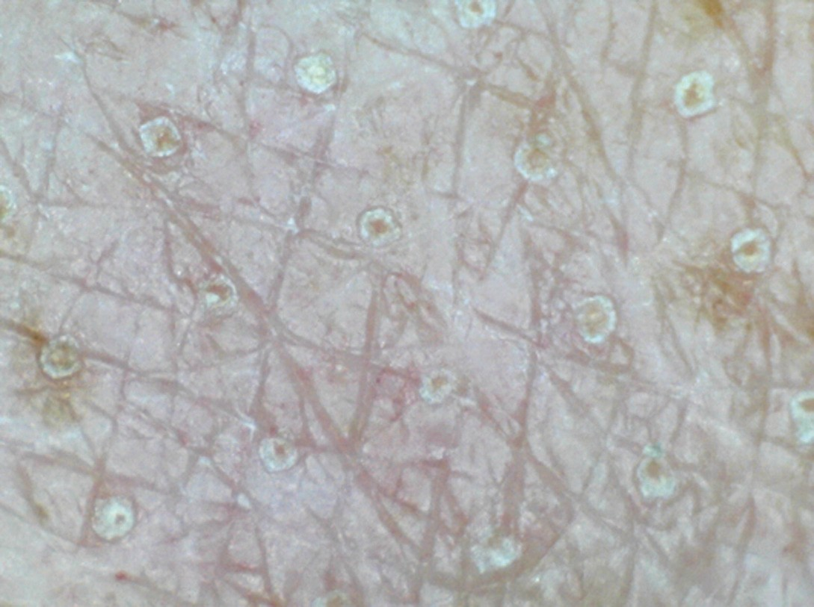
Figure 3. microscope view of human skin immediately after treatment in which the array of coagulation points can be detected. parameters: d tip, 9-ms double pulse.

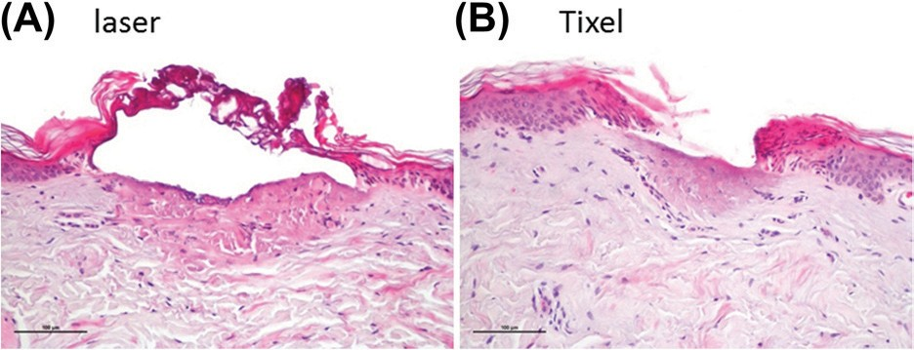

Figure 4. histopathology of (a) laser and (B) tixel immediately after treatment of human skin. Both craters present epidermal evaporation and dermal coagulation of the papillary dermis. laser (Quanta, youlaser, 24 W, 36 mJ/crater), tixel (ablative mode, d tip, 9-ms double pulse).

the Tixel device applying either the D tip or the S tip at 9–16-ms single pulse. This study was a review of records retrospectively assessed by the investigator. Each session included an evalua- tion of the pain level during treatment, downtime and time to clearance of erythema. Face images at frontal, right oblique, and left oblique positions were acquired via a Canfield Reveal Imager before and after each session. Subject satisfaction was assessed at the follow-up session.
All patients applied Biafine or Cicalfate lotions following treatments, and were allowed to use sunscreen cream (SPF 50) and unperfumed makeup once microcrusting appeared.
In all cases, pain level has been graded on a scale of 1–10 by the subject where 1 is no pain and 10 is very painful. Tixel treatments were performed without applying any sort of analge- sic substances or cooling.
The average  standard deviation of downtime, clearance of redness, and pain level were reported, for all sessions combined.

Histopathology
Biopsies were taken from the forearms and upper arms of two male volunteers, immediately after treatment with Tixel at
a range of parameters. In addition, CO2 laser was applied for histopathology comparison (YouLaser, Quanta, 24 W, 750 μs, 2 stacks, density: 100 spots/cm2, 36 mJ/point and Lumenis 1080 s, CW, 30 W, 50 ms/Pulse combined with Alma fractional Pixel
CO2 Omnifit handpiece, 9  9 array in 11  11 mm treatment zone). Histologies were evaluated in a blinded manner by the
histopathologist.
In addition, a female domestic swine (7 weeks old, Kibbutz Lahav, Israel) was in vivo submitted to triplicates of Tixel treat- ments at the dorsal flank. Skin biopsies were extracted imme- diately after treatment and 7 days after treatment. Histologies were analyzed by a blinded histopathologist. The study was approved by the ethical committee of the Pre-clinical Research unit of Assaf Harofeh Medical Center.

Results

Crater characterization
Fractional TMA of skin utilizes pre-heated tips to generate a matrix of craters in the skin surrounded by healthy tissue (Figure 3). The clean craters shown in the figure have a coagu- lated diameter of about 320 μm on the skin surface correspond- ing with an active area of roughly 10%.

Tixel vs. laser
Figure 4 presents histopathology of laser versus Tixel craters at typical treatment parameters of both devices. An ablative Tixel crater using the D tip, 9-ms double pulse is compared
with a CO2 laser crater. Fractional thermal ablation with Tixel created a lesion 160 μm in diameter (vs. 320 μm with laser)
and a thermal damage with dermal coagulation of the papil- lary dermis (depth of 170 μm, same as laser). Although Tixel and CO2 laser craters have a general similarity, in contrast to the laser crater, the Tixel crates are clean of necrotic tissue or charring.

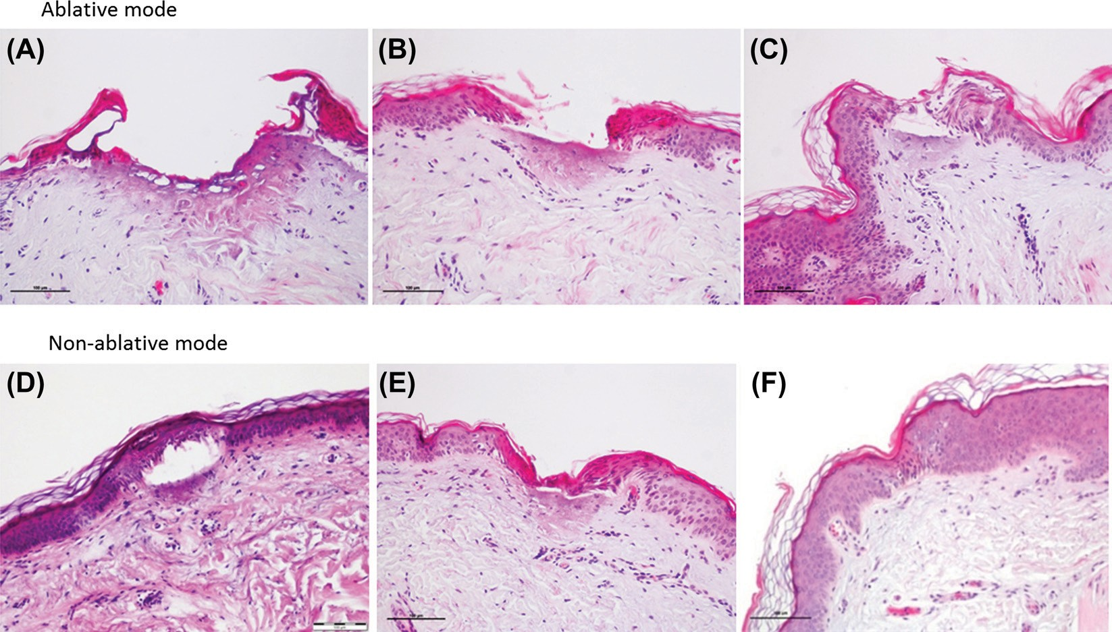

Figure 5. histopathologies of tixel treatments, at different settings, immediately after treatment of human skin. (a) d tip, 14-ms double pulse. (B) d tip, 9-ms double pulse.
- d tip, 9-ms single pulse. (d) s tip, 14-ms single pulse. (e) s tip, 9-ms double pulse. (f) s tip, 9-ms single pulse.

Table 1. summary of crater characteristics.
thermal damage thermal effect on

figure depth μm Width μm dermis epidermis

tixel pulse duration

tip type device

4a 170 330 Coagulation of upper papillary dermis ablation Vaporized – – laser Co2 5a 180 380 Coagulation of upper papillary dermis ablation Vaporized 14 ms double d tixel
5B 170 160 Coagulation of upper papillary dermis ablation Vaporized 9 ms double d tixel 5C 160 200 Coagulation of upper papillary dermis ablation Vaporized 9 ms single d tixel 5d 165 210 Coagulation of upper papillary dermis non-ablation Coagulated Vacuolation 14 ms single s tixel 5e 170 160∗ Coagulation of upper papillary dermis non-ablation Coagulated Vacuolation 9 ms double s tixel 5f 100 100 normal non-ablation Coagulated Vacuolation 9 ms single s tixel
∗internal crater width measurement.

Tixel crater variety
Crater properties and extent of thermal damage with Tixel are closely related to the choice of the tip, the pulse duration, and the number of pulse repetitions. The D tip creates ablative cra- ters (Figure 5A–C) while the S tip creates non-ablative thermal lesions (Figure 5D–F). Table 1 summarizes the main character- istics of craters at several Tixel pulse durations. Lesion dimen- sions are 100–380 μm wide and 100–180 μm deep. The histology shows no hemorrhage or edema.
The D tip generated clean epidermal evaporation and a der- mal coagulation of maximum 180 μm in depth, which corresponds to the upper papillary dermis.
The S tip had a milder effect. The coagulated epidermis is preserved, forming an essentially dressed crater. The epider- mis is compressed by the tip contact and the extracellular space between the cells is increased due to cell shrinkage. A process of vacuolation takes place and a cleft is formed between the dam- aged epidermis and dermis, as can be seen in Figure 5D and E, or a mild vacuolation in Figure 5F. In this later case, dermal coagulation at the upper papillary dermis is avoided due to the very brief pulse that has been applied.
The thermal model for ablation with Tixel shows the extent of the evaporation and thermal damage as a function of pulse duration, for both S tip and D tip (Figure 6). There is a pro- found difference between S and D tips in the extent of the abla- tive damage. The simulation predicts that the D tip ablates a considerable amount of tissue; while the S tip performs only minimal ablation. Simulation for a 9-ms single pulse is com- patible with the histological results presented in Figure 5. The
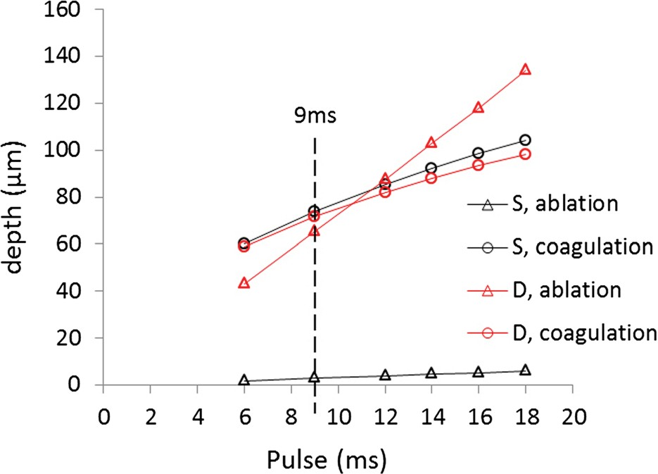
Figure 6. theoretical thermal model of tixel, with d tip and s tip, showing the extent of tissue ablation and tissue coagulation during various pulse durations.
D tip that evaporated the whole epidermis (Figure 5C) presents a calculated 65-μm ablation (Figure 6 red triangle); the S tip that induced a non-ablative lesion (Figure 5F) presents a calculated 5-μm ablation (Figure 6 black triangle). This can be explained by the differences between their thermal diffusion coefficients. The D tip heat transfer rate to tissue is much faster than the S tip. For the 9-ms pulse duration, the model also predicts that ablation occurs in the first 0.25 ms for the D tip and in the first 0.01 ms for the S tip. Tissue ablation is thus a considerably rapid event when compared with the entire pulse length. Fur- thermore, the thermal damage that was calculated to be about 74 μm for both cases (Figure 6 circles) also matches the histolo- gies. The coagulation damage, created during tip progression in the tissue, is determined by the thermal diffusivity of the tissue rather than the thermal diffusivity of the tip; and since both tips are in contact with tissue for a similar duration, a similar extent of tissue coagulation is expected.

The healing process
Histologies on the same day of Tixel treatment and after 7 days, on an in vivo porcine model, were examined (Figure 7). A Tixel crater 250 μm wide, 170 μm deep with focal necrosis of the epidermis and focal underlying dermal coagulation is pre- sented (Figure 7A). Seven days after, epidermal regeneration is observed with a surface crust and a dermal epidermal cleft (150  50 μm) filled with new fibroblasts and macrophage cells (Figure 7D), indicating that healing occurs normally. This effect is associated with new collagen formation. A non-ablative pulse is also presented where the epidermis and stratum corneum are not ablated (Figure 7B). Rather they are compressed. A cleft is formed in the epidermal–dermal junction and minimal super- ficial necrosis is seen in the dermis. Seven days after (Figure 7E), there is complete epidermal regeneration with a focal crust on the stratum corneum and minimal dermoepidermal cleft with focal collagen degeneration and macrophage infiltration. A low-energy non- ablative crater is associated with minimal epidermal damage with vacuolation at the epidermal–dermal junction and no dermal coagulation (Figure 7C). After Seven days, complete regeneration of the epidermis with minimal crust and underlying minimal collagen degeneration is observed (Figure 7F).

Clinical results
All subjects (100%) agreed or strongly agreed in both studies that no analgesics or pain relievers are necessary during the treatment.

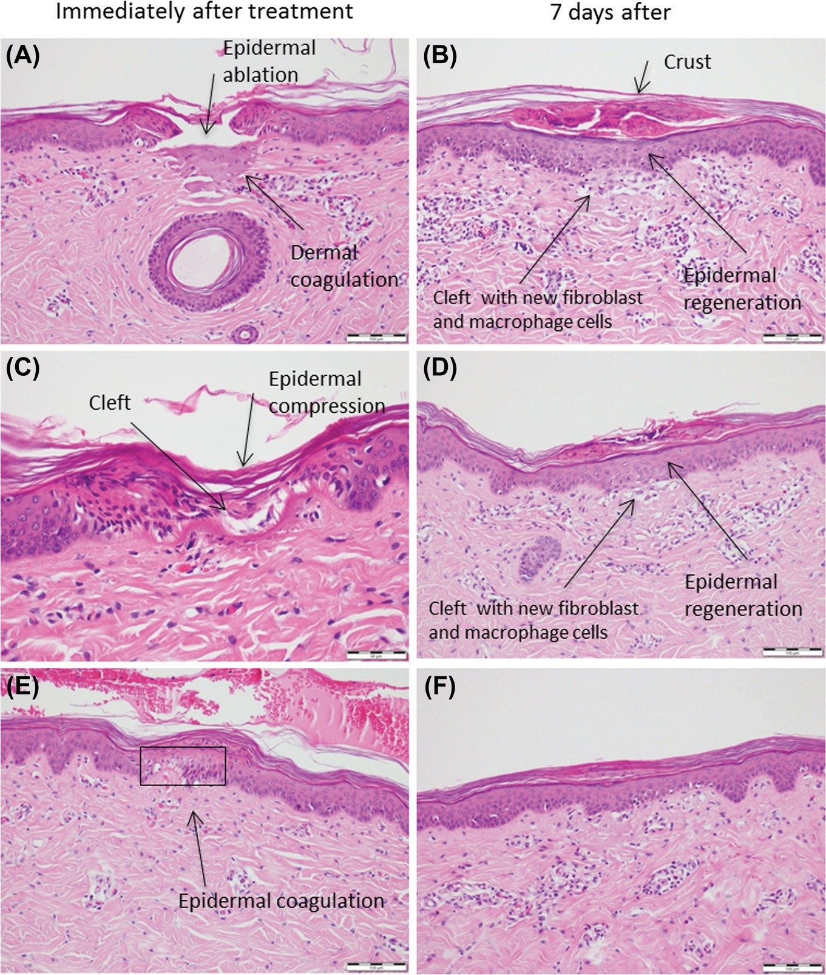

Figure 7. tixel histologies with s tip on in vivo porcine skin immediately after and 7 days after treatment. (a,d) ablative mode with high-energy pulse, (B,e) non-ablative mode with medium-energy pulse, (C,f) non-ablative mode with low-energy pulse.

Subjects’ average treatment pain without analgesia was 3.3  2 (n  13) for group 1 and 3  1.5 (n  56) for group 2 (pain scale: 1 minimum to 10 maximum). Downtime was short in the two groups, ranging from zero to one day for group 1 and no down- time in group 2 (91% of treatment sessions, n  57), independently of the tip type. The erythema resolved within 2–3 days for the 2 groups and in a few cases involved in more aggressive ablative treatment (i.e., D tip, 16 ms) within 4–6 days. In both groups of subjects, 75% were either satisfied or very satisfied at the follow-up visit, 1 month after third session.
All subjects have presented improvement in skin complex- ion or reduction of photo damage. In addition, in group 1 87% and in group 2 69% of subjects presented wrinkle attenuation with an average of 75% for both groups (Figures 8–10). Clini- cal results are summarized in Table 2. Improvement in skin complexion and in some cases in wrinkles was visible after the first treatment session with further improvement after the fol- lowing sessions. In one subject who did not take prophylactic treatment, herpes was reactivated. There was no incidence of bleeding, scarring, or post-inflammatory hyperpigmentation. Figure 11 shows the erythema immediately after treatment and the apparent microcrusting after 5 days.

Discussion and conclusions
Tixel fractional treatment is a novel thermal resurfacing treat- ment which can generate ablative as well as non-ablative micro-craters in the skin. Superheating water molecules in the skin tissues with a high- conductivity metallic tip is effective in vaporizing the skin cells in a safe, precise, and predictable effect.
Tixel’s D tip creates ablative craters with similar properties to
fractional CO2 lasers. At the settings applied, Tixel’s S tip gen- erates non-ablative “dressed” craters with underlying thermal damage extending down to the papillary dermis. The epider- mal dressing of the crater enhances the healing providing rapid re-epithelialization and epidermal regeneration of the lesion. Moreover, the crater’s cover may act as a natural physiologic dressing protecting from post-treatment infection during the healing process.
This technology is safe and offers good resurfacing results, with nearly no downtime. Craters with diameters narrower than those of laser crater are associated with rapid healing. As treatment downtime is very short, additional treatments can be performed as compared with fractional ablative and non- ablative lasers for optimal outcome.

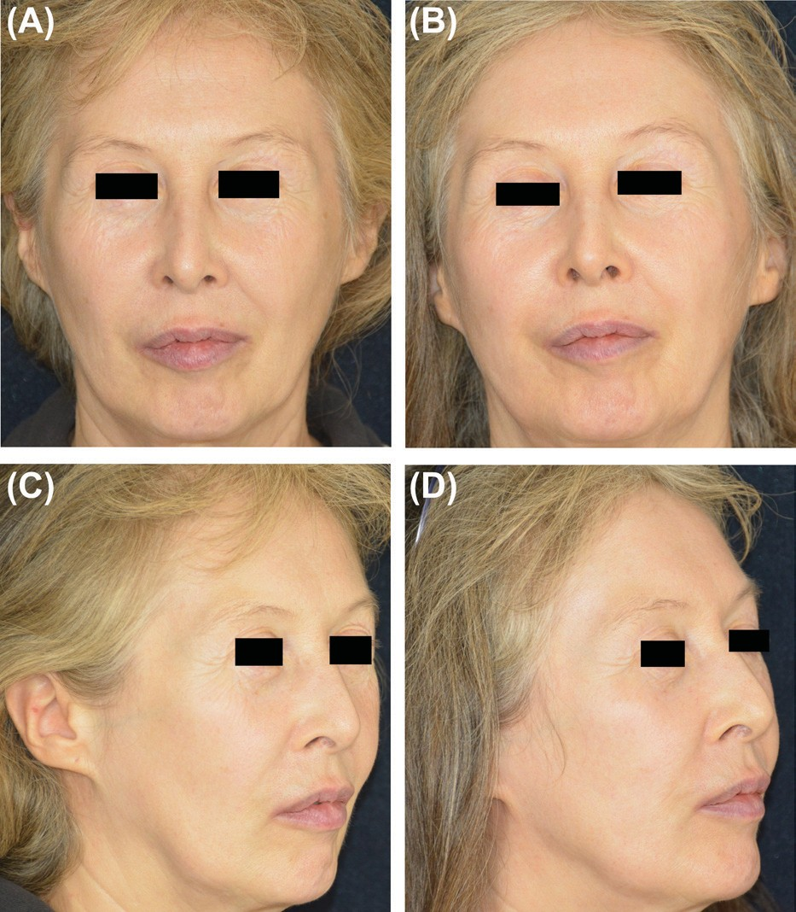

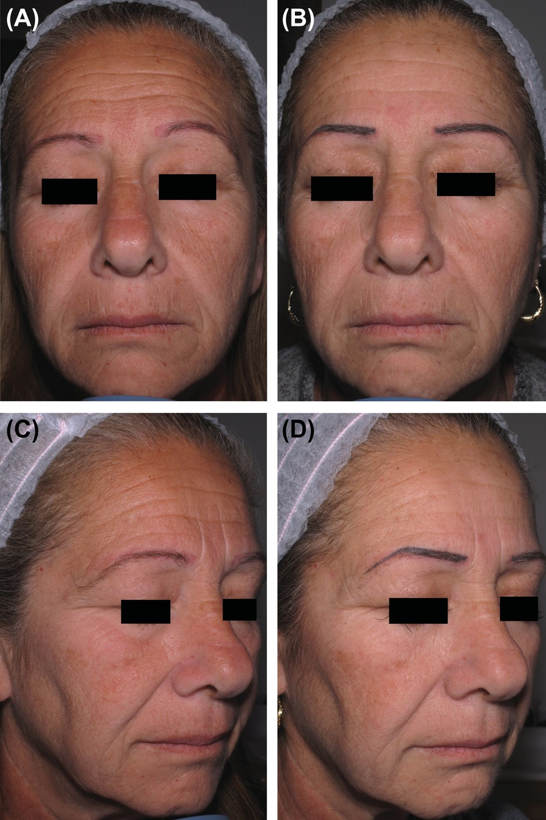
Figure 8. full-face treatment. (a,C) Before and (B,d) after 4 months from the 3rd treatment session with d tip, 9–14-ms single-pulse one pass. Woman 58 years, phototype iV.

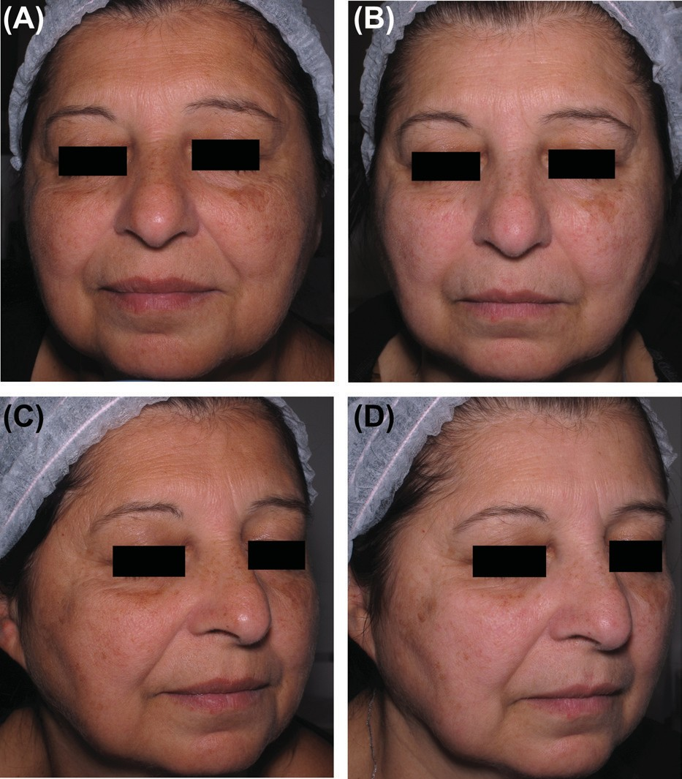
Figure 9. full face treatment. (a,C) Before and (B,d) after 4 months from the 3rd treatment session with d tip, 9–14-ms single-pulse one pass. Woman 58 years, pho- totype iV.
Figure 10. periorbital treatment. (a,C) Before and (B,d) after 1 month from the 2nd treatment session with d tip, 14-ms single-pulse one pass. Woman 59 years, phototype ii.

Table 2. Clinical results, groups 1 & 2.
number of subjects 26
treatment pain levela,b 3.1
downtimeb 0.16 days
Clearance of erythemab 3.5 days
subject’s satisfaction 75%
Wrinkle attenuationc 75%

ain a scale of 1 minimal to 10 maximum, without analgesia or pain relief.
bmean score.
cpercent of subjects that present wrinkle improvement.

Treatment presents low discomfort for the patient. The device is operator-friendly as there is no smoke, no protective eyewear is required, and there is no risk of accidental harm by invisible laser radiation on the patient, physician, or personnel. Treatment pain is low, not requiring the application of analgesic creams. Contrary to lasers, which require analgesia and cooling to limit the patient’s pain, Tixel patients did not ask for any pain

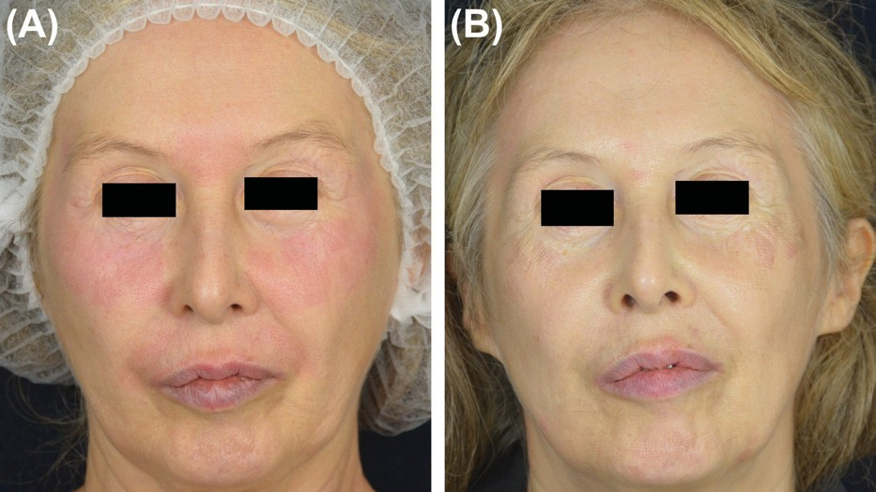
Figure 11. periorbital treatment. (a) immediately after treatment, (B) 5 days after treatment with d tip, 14-ms single pulse. Woman 59 years, phototype ii.

relief during treatment or afterward. The low pain level experi- enced is probably the result of several factors: (a) smaller diam- eter craters in comparison to lasers; (b) while overall energy applied per crater is similar to laser, Tixel employs a fraction of the energy density; (c) The entire matrix of 81 Tixel craters is created in a single step lasting about 15 ms whereas a single laser beam having much higher energy density is applied within 0.5 ms repeatedly close to 100 times to generate 1-cm2 treatment site. While further studies should be conducted to explore this new technology, this clinical evaluation was useful in provid- ing both quantitative and qualitative understanding of Tixel’s capabilities.
In conclusion, Tixel is a promising versatile fractional system for both ablative and non-ablative resurfacing.

Note
Some aspects of the TMA technology are patented and other aspects are patent pending.

Declaration of interest
All authors state lack of conflict of interest. The authors may be compen- sated in the future with company options.

References
  - Railan D, Kilmer S. Ablative treatment of photoaging. Dermatol Ther. 2005;18:227–241.
  - Bronz G. Clinical uses of CO2 lasers in plastic surgery. Aesthetic Plast Surg. 2001;25:313–325.
  - Saluja R, Koury J, Detwiler S, Goldman M. Histologic and clinical response to varying density settings with fractionally scanned carbon dioxide laser. J Drugs Dermatol. 2009;8:17–20.
  - Choi B, Chan EK, Barton JK, Thomsen SL, Welch AJ. Thermographic and histological evaluation of laser skin resurfacing scans. IEEE Journal of selected topics in Quantum electronics. 1999;5: 1116–1126.
  - Lask G, Elman M, Fournier N, Slatkine M. Fractional vaporization of tissue with an oscillatory array of high temperature rods – Part I: Ex vivo study. J Cosmet Laser Ther. 2012;5:218–223.

