Journal of Cosmetic and Laser Therapy, 2012; 14: 218–223

ORIGINAL RESEARCH REPORT

Fractional vaporization of tissue with an oscillatory array of high temperature rods – Part I: Ex vivo study

GARY LASK1, MONICA ELMAN2, NATHALIE FOURNIER3 & MICHAEL SLATKINE4

1UCLA Medical School, Los Angeles, CA, USA, 2Beit Harofim, Holon, Israel, 3CLDP, Clapier, France, and 4Nova-B Ltd., Hadera, Israel

Abstract
Background: Short pulse duration (∼0.1–5 milliseconds) CO2 lasers are perceived as excellent tools for vaporization of craters arrays in fractional skin resurfacing. Objectives: To present a thermo-mechanical ablation technology, which affects tissue identically to fractional CO2 lasers, however at a fraction of the size and cost of a laser. Material and methods: The new technology is based on heating an oscillating array of thin metallic rods to a temperature of 400°C and advancing the rods into tissue down to a precise pre-selected depth for a duration of 0.1–5 milliseconds. As a result, an array of crater is vaporized with identical properties of those produced by CO2 lasers. An ex vivo test was performed with a thermo- metallic rod array prototype. Results: Arrays of 10 × 10 vaporized micro-craters of 350 micron diameter, 200 micron depth have been produced with lateral thermal damage of 80 micron while thermal damage below craters was 80–250 micron. Conclusions: A resonating thermo-mechanical array of high temperature (350–400°C) rods is capable of producing an array of craters identical to those produced with pulsed CO2 lasers.
Key Words: skin resurfacing, CO2 lasers, fractional, wrinkles

Introduction
Short pulse CO2 lasers are generally considered among the best tools for high precision ablation of thin layers of tissue without bleeding and with mini- mal collateral damage (1). They are widely utilized in skin resurfacing, including fractional skin resurfacing (2,3). By operating a 10.6 micron CO2 laser with energy density above a threshold of ∼5 J/cm2 and pulse duration below few milliseconds (0.1–5 milli- seconds), vaporization rate is faster than thermal dif- fusion into tissue and collateral thermal necrosis is
∼100–150 micron. With only 30–50 micron penetra-
tion of the 10.6 micron wavelength laser beam into tissue, it is possible to vaporize craters arrays of skin down to or deeper than the papillary dermis and achieve excellent skin resurfacing results. With an array of ∼100–500 micron focused beam spots, frac- tional resurfacing of ∼12–20% of the skin surface ensures fast healing. The energy responsible for the vaporization of tissue with a CO2 laser is purely ther- mal. The tissue parameters, which quantitatively dic- tate the threshold energy for vaporization with only
100–150 micron collateral damage, are the vaporiza- tion energy of tissue which is ∼3000 J/cm3 (4) and the beam penetration in tissue (30–50 micron). In the vaporization process, temperature craters produced by a single pass laser beam attain ∼350° C (5).
Since thermal energy is responsible for tissue vaporization, we may expect that by bringing a metal- lic element of temperature ∼350° C in contact with the skin for a duration of less than ∼0.1–5 millisec- onds and depth ∼50–250 micron, a clinical ablative effect which is identical to the CO2 laser effect will occur. However, such extremely fast and accurate thermo-mechanical procedure with a 350° C array enclosed in a small size comfortable handpiece requires very specific geometrical, mechanical and thermal design, which has recently been developed in our laboratory. The objective of the current article is to describe the general design principles a the new ‘ThermiXel’ thermo-mechanical technology, which acts identically to a short pulse CO2 laser and can be used in a variety of surgical applications including fractional skin resurfacing. The advantage of the

J Cosmet Laser Ther Downloaded from informahealthcare.com by Athlone Institute of Technology on 07/15/14 For personal use only.

Correspondence: Gary Lask, MD, UCLA Medical School, Dermatology, 200 UCLA Medical Plaza, Los Angeles, CA, United States. E-mail: micslatk@ zahav.net.il

(Received 18 October 2011; accepted 5 May 2012)
ISSN 1476-4172 print/ISSN 1476-4180 online © 2012 Informa UK, Ltd. DOI: 10.3109/14764172.2012.698284

technology is its very low cost as compared to a laser as well as its small size. In the following, we shall present an ex vivo confirmation of the expected results of crater vaporization in tissue with an oscil- lating thermo-mechanical element.

The ‘ThermiXel’ technology1
The new tissue ablation technology is based on the supply of vaporization heat from an extremely hot (∼350–400°C) array of miniature rods down to a pre- selected depth (50–250 microns) in tissue within
∼0.1–5 milliseconds, thus mimicking the pulsed CO2 laser action. As is shown below, this can be practically realized in a small device due to exploitation of a fortunate coincidence of thermal characteristics of some metals and tissue.
their oscillatory journey depends on the initial com- pression loading force (spring constant × loading amplitude) and can be practically set to ∼0.1–5 mil- liseconds. This implies that the vaporizing rods stay in the skin for that time duration. As a result, an array of vaporized craters (Figure 1C) is formed in the skin within ∼0.1–5 milliseconds, which is similar to craters formed by a many pulsed ‘Fraxel’ CO2 laser of same pulse duration (6).

Theoretical analysis – selection of operational parameters
The following conditions are prerequisites for the high temperature rods to practically mimic high quality CO2 (as well as Erbium) lasers operation as describes above:

Operating principles
The operating principles of the ‘ThermiXel’ technol- ogy are schematically presented in Figures 1A–C. A high thermal conductive copper block with an inte- grated array of copper rods is located inside a hand held treatment handpiece and is heated by a high power (∼100 W) miniature electric heater cartridge to a temperature of 350–400°C. The high temperature block is held in a loaded position by a compressed spring. A thermally isolated protective plate (which may be chilled to a temperature of ∼10°C) with a cor- responding array of holes serves as the distal end of the treatment handpiece and is placed on the skin to be treated. Once the handpiece is placed on the treat- ment site and a treatment command is given by the operator, the high temperature block/rods unit is released and allowed to move forward and perform a single harmonic oscillation (with the aid of the attached spring) of ∼30 milliseconds duration, with an ampli- tude which is set to allow all rods penetrate a prese- lected distance (of 50 – 250 micron) into the skin (Figure 1B). A thermally insulating spacer provides additional assurance of penetration depth accuracy. Since the rods penetration into the skin occurs when the spring is fully stretched and copper block velocity is decelerated to zero, there is no mechanical impact on patient. Once the vaporizing rods have ‘flicked’ a thermal impact into the skin, the stretched spring returns the oscillating element back to its original retained position where it is reheated and gets ready for the next treatment command. We note here that the rods do not affect tissue at all if not heated, as opposed to mechanical needles. An analysis of the copper block movement reveals that the dwelling time of the rods in their distal 50–250 micron section of
(a)

(b)

(c)

(d)

(e)

(f)
The thermal energy, which is stored in the distal end of each rod, should be equal to (or higher than) the latent heat of vaporization of tissue for a volume equal to the vaporized crater volume.
The thermal energy should be delivered within
∼0.1–5 milliseconds (depending on depth), namely: the thermal relaxation time of the thermal energy storage section of the rod should be shorter than ∼0.1–5 milliseconds. Rods (as well as copper block) should attain a temperature of ∼350–400°C in order to mimic pulsed CO2 laser action (5) as well as avoid sticking of tissue to the metallic rods and, as shown below, provide the necessary vaporizing energy.
Treatment repetition rate should be high enough – at least 1 Hz as achievable by most pulsed CO2 lasers with treatment spot size
∼10 × 10 mm2, for an unlimited number of treatment spots. This implies temperature rise of rods distal tip within < 1 second fol- lowing each treatment ‘flick’ and movement to the next treatment spot, without gradual decrease of distal end temperature.
Initial heating up of the fixed metallic block to a temperature of 400°C prior to a treat- ment session should practically take only a few minutes. On the other hand, the pre- heated block should be large enough since it serves as a passive energy reservoir for the vaporizing rods. Yet, it should be small enough to be integrated in of a small hand held treatment handpiece.
The treatment device should be hand held and only few centimetres in size.

J Cosmet Laser Ther Downloaded from informahealthcare.com by Athlone Institute of Technology on 07/15/14 For personal use only.

1Note: The ‘ThermiXel’ technology is patent pending.
- Adjustment of dwelling time duration in tissue
In the process of vaporizing tissue craters of depth
H, the copper block and rods array (of total mass M)

(A)
Electrical leads

Spring

Oscillating copper block with rods array in preloaded compressed position

Thermally Insulated and chilled hand held
housing (details not shown)
100 W miniature cartridge heater

Insulating stop spacer

Chilled Protective plate with holes

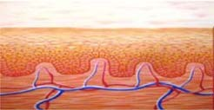(B)

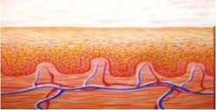Oscillating copper block with rods array in fully extended tissue vaporizing position

Vaporizing rods protrude preselected depth H into tissue

Copper block is stopped by spacer at almost zero velocity

Chilled Protective plate with holes

(C)
12 -25% treatment area

100-400 micron 60-150 micron 0.5-1 mm
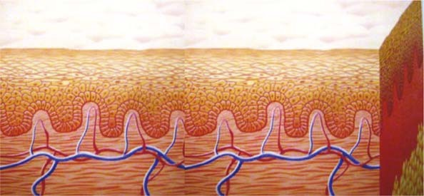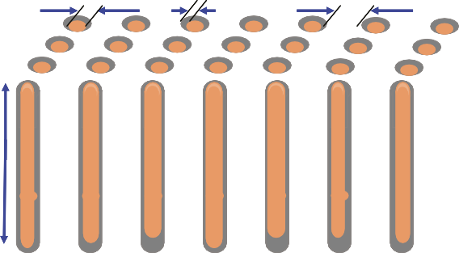
30-200
micron

Figure 1. (A) The operating principle of ‘ThermiXel’ technology. High temperature array of treatment rods in upper spring loaded position.
(B) The operating principle of ‘ThermiXel’ technology. High temperature array of treatment rods in lower spring stretched position while vaporizing craters. (C) Schematic presentation of craters array produced ‘ThermiXel’ technology.

are located at the distal end of their oscillatory track, with zero velocity. As schematically shown in Figure 2, the restoring force F induced by the stretched spring accelerates the mass M away from tissue back to its original loaded position. The acceleration a of the mass M is a = F/M, and the time duration t
J Cosmet Laser Ther Downloaded from informahealthcare.com by Athlone Institute of Technology on 07/15/14 For personal use only.
needed for the rods to leave tissue (or travel a dis- tance H) fulfils the equation:
H = at²/2 = Ft²/2M. (1)
As a result, t = √(2MH/F). The dwelling time in tissue is twice as long, since the rods array is

The rate of heat flow W from a rod of length L, width d, thermal conductivity K and a temper- ature T above the temperature of the tissue is approximately:
Initial loaded position
X0

End point of oscillation: Velocity zero; Upward acceleration a=F/M = kX0/M
–X0
Restoring force F=K X0
Velocity=0
H
Skin surface

W = KTd²/L = E/t, (6)
where t denoting the rods ‘flicking’ duration or vapor- ization time duration, as well as the duration of deliv- ery of thermal energy from the rod to tissue. This implies:

Figure 2. Model for analysing the dwelling time of vaporizing rods in tissue.

decelerated prior to the backward acceleration, implying:
t ∼ HvaporizHL/KT. (7)
For L ∼ 650 micron, T ∼ 400°C, K (copper, 400°C) = 2 W/cm °C and H = 100 micron we obtain,
t ∼ 2 milliseconds.

t dwelling = 2√(2MH/F). (2)
As explained in the section ‘Experimental results’, our design parameters were: M = 150 g; H = 100 micron; F = KX, K = spring constant = 8 kg/cm; X = loading distance (spring compression) = 10 mm. According to Equation (2), this implied dwelling time ∼1 milliseconds. Dwelling time duration is pro- portional to √H and can be adjusted by varying the initial compression F (by varying the distance X).

- Thermal parameters
We hereby calculate the thermal parameters of the metallic rods, which can fulfil the stated above prerequisites.
The energy E needed to vaporize a crater with, for example, a square shape of width d and a depth H is:
These results lead to the following observations:
The distal end of length 650 micron of a copper rod, which is elevated to a temperature of 400°C, can provide the necessary energy to vaporize a 100 micron deep crater in tissue within ∼2 milliseconds. Shorter time durations are achievable with higher compression or smaller size copper blocks (smaller mass M).

- Treatment repetition rate
The treatment repetition rate has been analysed by solving the one dimensional heat Equation (7)
∂²T/∂²X = 1/α²∂T/∂t (α²= K/cρ), (8)
for the flow of heat in the treatment rods (of 10 mm length) with boundary conditions: T = 400°C on the proximal end of the treatment rod and T = 37°C on

E = H
d2H, (3)
the 650 micron distal section each time rod is in

vaporiz
vaporiz
contact with tissue for a duration of 1 millisecond.

where Hvaporiz is the latent vaporization energy of 1 cm3 of tissue (approximately 3000 J/cm3) (6).
J Cosmet Laser Ther Downloaded from informahealthcare.com by Athlone Institute of Technology on 07/15/14 For personal use only.
The thermal energy E, which is stored in a distal length L of the vaporizing metallic rod and may be available for vaporizing tissue, is given by:
E = CLd2T, (4)
where C = heat capacity, ρ = vaporizing rod material density, T = rod temperature (∼400°C).
Based on the first pre-requisite, namely E > ∼Evaporiz
and equations (3) and (4):
L > ∼HvaporizH/(CρT). (5) In the case of a copper rod, C ∼ 0.4 J/g °C; density:
ρ ∼ 9 g/cm3, implying that for a vaporization depth
H = 100 micron.
L > ∼650 micron.
Namely, the vaporizing energy flows into the skin from a distance of 650 micron in the rod.
We assume that during that period of time, rod distal end is emptied from its thermal energy (heat has flown to tissue and vaporized a crater), and we use Equation (8) to find out how fast the rod distal end is recharged with heat for the next treatment.
Figure 3 presents the solution to Equation (8) and shows that a repetition rate as high as 1 Hz is attainable with the ‘ThermiXel’ technology for an unlimited number of treatments.

- Residual heat
In similarity to CO2 laser treatments, the heat accu- mulated in the ∼50–150 micron width coagulated zone (initially at 100°C) which surrounds the vapor- ized craters, diffuses to surrounding tissue and ele- vates its temperature. By chilling the skin to a temperature of 10°C for a short time duration of
∼0.5 seconds (depth of ∼0.5–1 mm) with the protec- tive plate before each treatment pulse, we increase the number of epidermal cells between the craters

Tip temperature vs. treatment speed
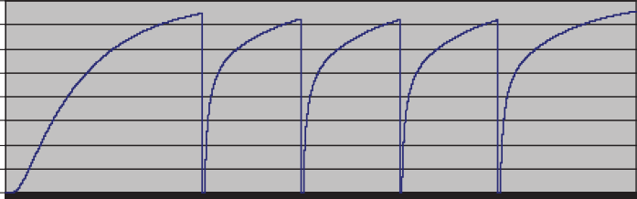
400
Tip temperature °C
350
300
250
200
150
100
50
0
0 2.0 3.0 4.0 5.0
Time (sec)

Figure 3. Speed of temperature recovery of rods array for 1 Hz treatment speed.

which do not sense any increase of temperature and allow faster healing.
J Cosmet Laser Ther Downloaded from informahealthcare.com by Athlone Institute of Technology on 07/15/14 For personal use only.

Experimental results
Experimental vaporizing unit
A 18 mm diameter and 40 mm length copper blocks with an integrated array of 10 × 10 rods (500 micron × 500 micron × 10 mm size rods, 1 mm spac- ing) has been produced (Figure 4). A miniature 100 W, high temperature heater was activated with a small 100 W, 24 V DC power supply. The copper block/rods array assembly attained a temperature of 400°C within ∼3 minutes as measured with a type K thermocouple.
The protrusion of the rods array beyond the skin contact plate (= skin vaporization depth) was preset to 50–250 micron. The oscillatory assembly was inte- grated into a handpiece, which was air cooled and comfortably hand held.
The rods protrusion time duration was electron- ically measured by monitoring the short circuit cre- ated between the copper rods and an aluminium foil, which was placed in electrical isolation under the handpiece and simulated the conductive skin surface.
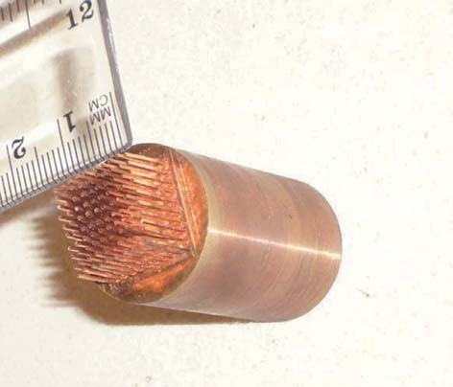
Figure 4. Treatment array (10 × 10) of high temperature (350– 400°C) copper rods. Rods width 100–500 micron. Separation: 1000 micron.
The measured short circuit duration was 2.5 milliseconds.

Ex vivo test
The ‘ThermiXel’ prototype has been tested on the shaved skin of the abdomen of domestic white pig cadaver (the fresh abdomen was purchased from a slaughter house). The skin surface was chilled to a temperature of 14°C with ice for a duration of
5 seconds prior to firing the treatment pulse. Ice

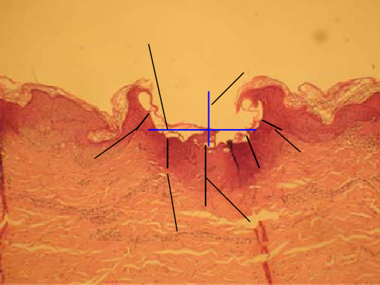(A)
380 micron
200 micron
80 micron
80 micron
120 micron
100 micron
250 micron

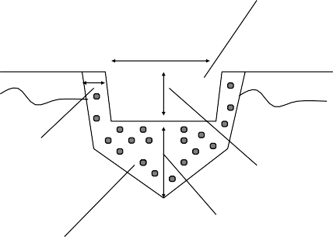(B)
Vaporized crater

380 micron

80 micron
200 micron
250 micron
Coagulated zone

Figure 5. (A) Cross section of a conical crater produced by ‘ThermiXel’ technology. Vaporized crater width: 380 micron; vaporization depth: 200 micron; collateral thermal damage: 80 micron on the sides and 250 micron at the centre. (B) Schematic presentation of the conical vaporized crater. Lateral coagulation zone is 80 micron wide. Vaporized craters as well as coagulation zone can be set to either conical or flat shape.

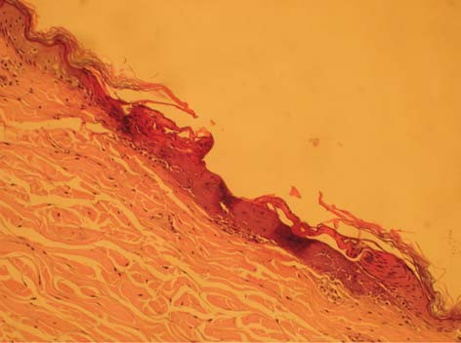while leaving the skin between the treatment spots intact. That operation generally mimics the operation of most scanning fractional pulsed CO2 (and Erbium) lasers. This is made possible with the selection of metals with high thermal conductivity at high tem- perature (T = 350–400°C) and the use of a single ‘flicking’ harmonic oscillation with short (0.1–5 mil- liseconds) dwelling time in tissue. With well-designed thermal isolation the treatment unit can be integrated in a small comfortably hand held handpiece and be utilized in fractional skin resurfacing. A multicentre clinical study for fractional skin resurfacing is cur- rently being initiated.
Collateral thermal damage
= 60 micron
Vaporization depth = 60
micron

Figure 6. Cross section of a flat shallow crater produced by ‘ThermiXel’ technology. Vaporization depth 60 micron; collateral thermal damage 60 micron.
J Cosmet Laser Ther Downloaded from informahealthcare.com by Athlone Institute of Technology on 07/15/14 For personal use only.

substituted the thermoelectric chilling of the protec- tive plate which has not been incorporated in the prototype. Figure 5A presents a histology section of a vaporized crater produced on the skin. The crater width is 380 micron, and the vaporization depth is 200 micron. Thermal collateral damage is 80 micron on the sides and 250 micron in a 100 micron wide cone in the centre. Figure 5B provides a schematic view of the crater. Figure 6 shows a very shallow flat crater which was obtained while setting the prese- lected rods protrusion distance from the skin plate to a lower value. Vaporization depth is 60 micron and collateral thermal damage is 60 micron as well.

Discussion and conclusions
We believe that we have demonstrated the capability to utilize arrays of high temperature metallic rods to vaporize deep as well as very shallow craters with minimal collateral thermal damage without char,
Declaration of interest: Michael Slatkine is cofounder of NovaB and its chief scientist. All other authors will be compensated in the future (in the form of payments/stock options) for running the multi- centre clinical trial and for serving in the medical advisory board of NovaB.

References
- Railan D, Kilmer S. Ablative treatment of photoaging. Der- matol Ther. 2005;18:227–241.
- Bronz G. Clinical uses of CO2 lasers in plastic surgery. Aesth Plast Surg. 2001;25:313–325.
- Saluja R, Koury J, Detwiler S, Goldman M. Histologic and clinical response to varying density settings with fractionally scanned carbon Dioxide laser. J Drugs Dermatol. 2009;8(1).
- Carruth JAS, McKenzie AL. Medical lasers – science and clinical practice. Bristol and Boston: Adam Hilger Ltd; 1986: p. 60, Ch. 3.
- Choi B, Chan EK, Barton JK, Thomsen SL , Welsh AJ. Ther- mographic and histological evaluation of laser skin resurfac- ing scans. IEEE J Select Top Quant Electron. 1999;5: 1116–1126.
- Le Pillouer-Prost A, Zerbinati N. Fractional laser skin resur- facing with SmartXide DOT. Initial Results. J Cosmet Laser Ther. 2008;10:78–84.
- Hildebrand FB. Advanced calculus for applications. Engle- wood Cliffs, New Jersey: Prentice/Hall; 1962: p. 429, Ch. 9.

